PR SERVICE MANUAL

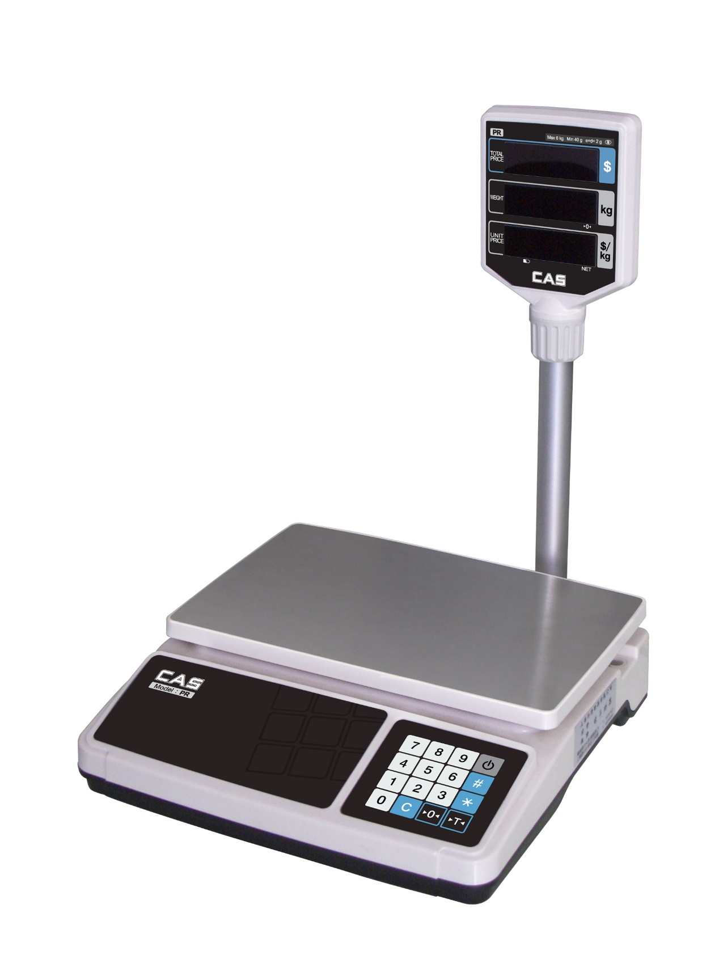
REV 0.1

1、Introduction

1.1 PREFACE
Thank you for the purchasing of our CAS PR Series.
This series have been designed with CAS reliability, under rigid quality control and with outstanding performance. Your speciality departments can enjoy with these high quality reliable CAS products.
We believe that your needs will be satisfied and you will have proper reliability in variable weight.
This manual will help you with proper operations and care of the PR series.
Please keep it handy for the future reference.

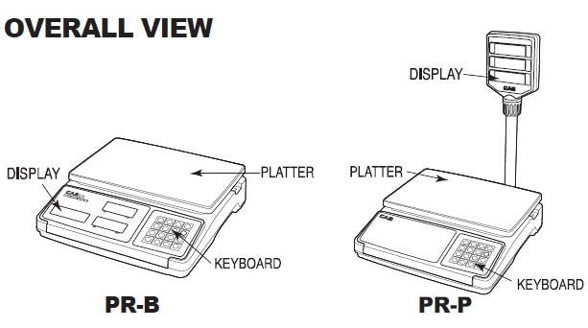

1.2 Specifications
MODEL | PR
CAPACITY  (DUAL) | 3 * 0.001Kg  (6 * 0.002lb) | 6 * 0.002Kg  (15 * 0.005lb) | 15 * 0.005Kg  (30*0.01lb)
CAPACITY  (SINGLE) | 6 * 0.002Kg  (15*0.005lb) | 15*0.005Kg  (30*0.01lb) | 30*0.01Kg  (60*0.02lb)
Maximum Tare | -6.000Kg | -9.995Kg | -9.990Kg
Temperature Range | - 10 °C ~ +40 °C
Power Source | 110V / 220V / 230V, 50Hz /60Hz
Power Consumption | APPROX. 10W
Display | Total Price 6 Digit  Weight 5 Digit  Unit Price 5 Digit
Plate Size | 340 (W) * 215 (W)

1) General Calibration
- Pressing and holding calibration switch press [POWER] key to go to calibration Mode

WEIGHING SPECIFICATIONS
⑴Single Capacity (Table 1)
No. | Capacity | Degree | Tare Range
0 | 3kg | 1g | 0 – 1.499kg
1 | 6kg | 2g | 0 – 2.998kg
2 | 15kg | 5g | 0 – 7.495kg
3 | 30kg | 10g | 0 – 14.99kg
4 | 6lb | 0.002lb | 0 – 2.998lb
5 | 15lb | 0.005lb | 0 – 7.495lb
6 | 30lb | 0.01lb | 0 – 14.99lb
7 | 60lb | 0.02lb | 0 – 29.98lb
⑵Dual Capacity (Table2)
No. | Capacity | Degree | Tare Range
8 | 6kg | （0 – 3kg）- 1g (3 – 6kg) – 2g | 0 – 2.999kg
9 | 15kg | （0 – 6kg）- 2g (6 – 15kg) – 5g | 0 – 5.998kg
10 | 30kg | （0 – 15kg）- 5g (15 – 30kg) – 10g | 0 – 9.995kg
11 | 6lb | （0–3lb）- 0.001lb (3–6lb) – 0.002lb | 0 – 2.999lb
12 | 15lb | （0–6lb）- 0.002lb (6–15lb) – 0.005lb | 0 – 5.998lb
13 | 30lb | （0–15lb）- 0.005lb (15–30lb)– 0.01lb | 0 – 9.995lb
14 | 60lb | （0–30lb）- 0.01lb (30–60lb) – 0.02lb | 0 – 29.99lb
⑶Single Capacity (Table3 High Resolution)
No. | Capacity | Degree | Tare Range
15 | 6kg | 1g | 0 – 2.999kg
16 | 15kg | 2g | 0 – 5.998kg
17 | 30kg | 5g | 0 – 9.995kg
18 | 6lb | 0.001lb | 0 – 2.999lb
19 | 15lb | 0.002lb | 0 – 5.998lb
20 | 30lb | 0.005lb | 0 – 9.995lb
21 | 60lb | 0.01lb | 0 – 29.99lb

1.4 DISPLAY
● LED 16 bits
● Weighting Display：5 bits
Decimal：
3kg Mode 3 bits decimal (0.000~3.000kg)
6kg Mode 3 bits decimal (0.000~6.000kg)
15g Mode 3 bits decimal (0.000~15.000kg)
30kg Mode 3 bits decimal (0.000~30.000kg)
6lb Mode 3 bits decimal (0.000~6.000lb)
15lb Mode 3 bits decimal (0.000~15.000lb)
30lb Mode 3 bits decimal (0.000~30.000lb)
60lb Mode 2 bits decimal (0.00~60.00lb)
● Unit Price Display：5 bits
● Total Price Display：6 bits
● Zero Point Indicator、Tare Indicator、Power Source Indicator、Low Battery Indicator、Accumulation Indicator

KEYBOARDS
Key Number：16
● Numeric Enter keys：[0]，[1]，[2]，[3]，[4]，[5]，[6]，[7]，
[8]，[9];
● Zero Set Key：[Zero]
● Tare Key：[Tare]
● Add/TTP Call Key：[#]
● Pay Key：[*]
● Nemeric Clear Key：[Clear]

Weighing Mode
⑴.Weighing with Tare
Tare Method：
Place the container on the platter，press TARE key。
⑵.Zero Set Range
Initial Zero ±The（2％，5%，10%，20%）Capacity
Zero Set Range ±The（2％，5%，10%，20%）Capacity
⑶.Unit Price Input
Numeric Enter [0] – [9]
⑷. Accumulation
When you have a few batch of things to weigh, place the commodity on the platter. Enter an unit price. Press [#] key to save weighing times and total price in memory. Meanwhile, display total amount and total price. Remove the commodity from the platter, repeat the above operation, can continue to accumulate.
. Display /Clear Previous Amount And Total Price
When no commodity on the platter, press [#] to display total
amount and total price. Press numeric key to continue to add up transactions for weighed commodities. Press [C] key to clear previous total amount and previous total price, and go back to the weighing mode.
⑹. Make Payment
When no commodity on the platter, press [#] to display total
amount and total price. Press [*], enter a customer’s payment displayed on the unit price display, and the amount of change is displayed on the total price display. Press [*] , to exit from the change mode, to go back to the weighing mode.

Battery Consumption Time
Battery specifications 4V/4AH, battery charging time 16 hours, 25 hours continuous use time. When the battery voltage drops below 3.8V, the low battery indicator lights. For the protection of battery over discharge, when the battery voltage is lower than 3.6V, the automatic shutdown.

2、Test Mode Introduction
- Power on to Enter Calibration Mode
Press [CAL] key, then press [ON/OFF] key and enter cal mode.
Display [ CAL ] three times, then show [C-1].Press [Zero] or Numeric keys to select one of C1~C5 item, press [Tare] key to get into C1~C5 mode.
Notice：Because the keyboard of the scale will test the key value and the battery voltage when enter into CAL mode, please unpress the [CAL] key, and no key will be pressed between display [CAL] and dsplay [C1].
When keyboard can not be used, please try again.
- C1 Set Weighing Specification
C1：Weighing Specification Set：0～14
Display [C1 x ] Showed In Table 1 and Table2.
- CLEAR MEMORY
C2：EEPROM Initiation
Press [Tare] Key to Initiate EEPROM.
- C3 Calibration
Display [ULoAd]
Press [Tare] Key, Confirm Zero Point。
Display [LoAd]
Load the poise, press [Tare]and wait a few seconds. If the weight loaded is just the same as the full range, press [Tare] complete this calibration. Or you should modify the value through Nemeric Key and Press [Tare] Key.
Notice：Calibration weighting value should not great than 10% of capacity.
- FUNCTION SET
C4-1:Initial Zero Range
[C4-1 0] 2% Full Range
[C4-1 1] 5% Full Range
[C4-1 2] 10% Full Range
[C4-1 3] 20% Full Range
C4-2: Zero Set Range
[C4-2 0] 2% Full Range
[C4-2 1] 5% Full Range
[C4-2 2] 10% Full Range
[C4-2 3] 20% Full Range
C4-3：Zero-Tracking Range
[C4-3 0] 1/4e
[C4-3 1] 1/2e
[C4-3 2] 1e
[C4-3 3] 2e
C4-4：Sleep Mode
[C4-6 0] Sleep Mode Off
[C4-6 1] Sleep Mode On
C4-5：Price Decimal Point Position
[C4-7 0] Unit Price, Total Price With 2 Decimal Point
[C4-7 1] Unit Price, Total Price With 1 Decimal Point
- AD Test
C5： Show Internal AD value
- Gravity constant
C6： Gravity constant
G1： Manufacturing place Gravity constant
G2： use place Gravity constant

3、Circuit Diagram (PR)
3.1 MAIN PCB

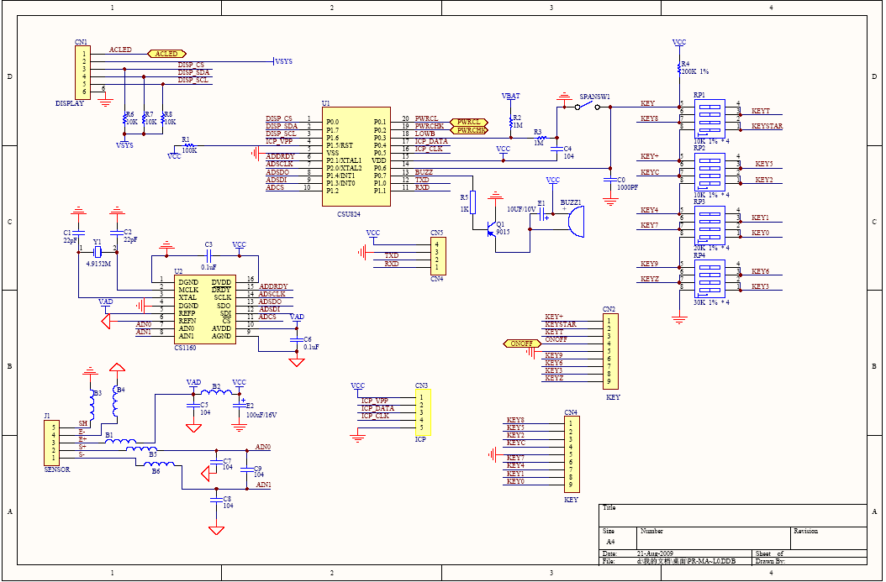

3.2 Power Part (Main PCB)

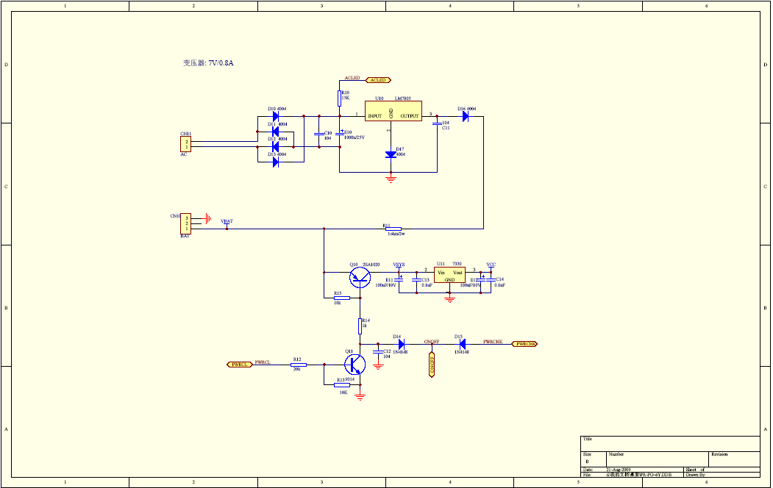

3.3 Display PCB （OP）

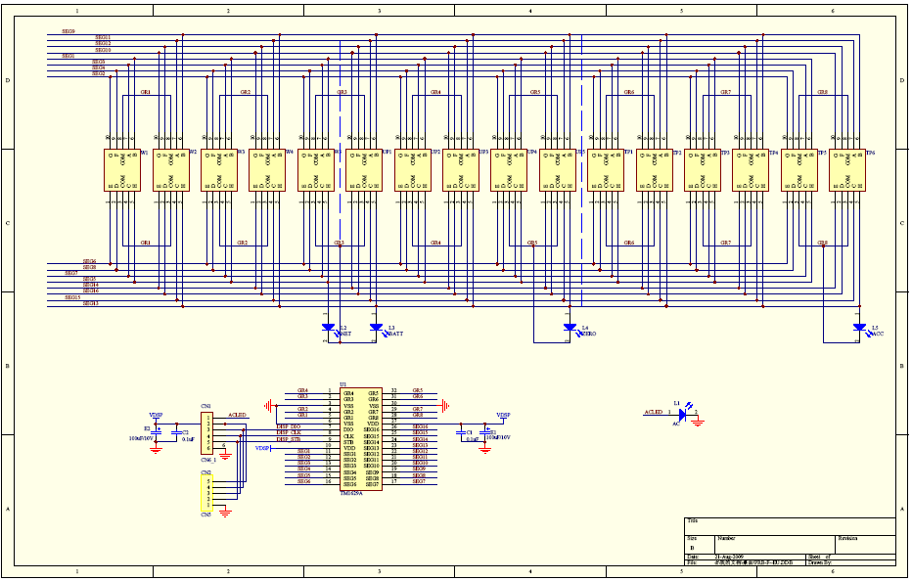

3.4 Display PCB (Cust)

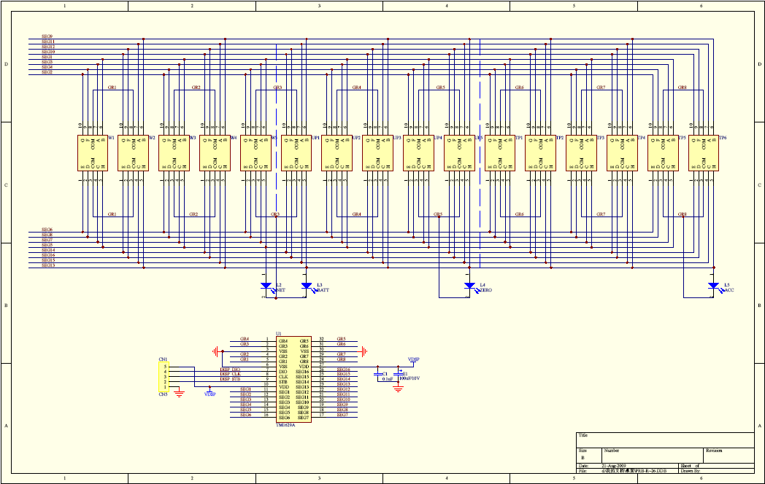

4、Exploded View
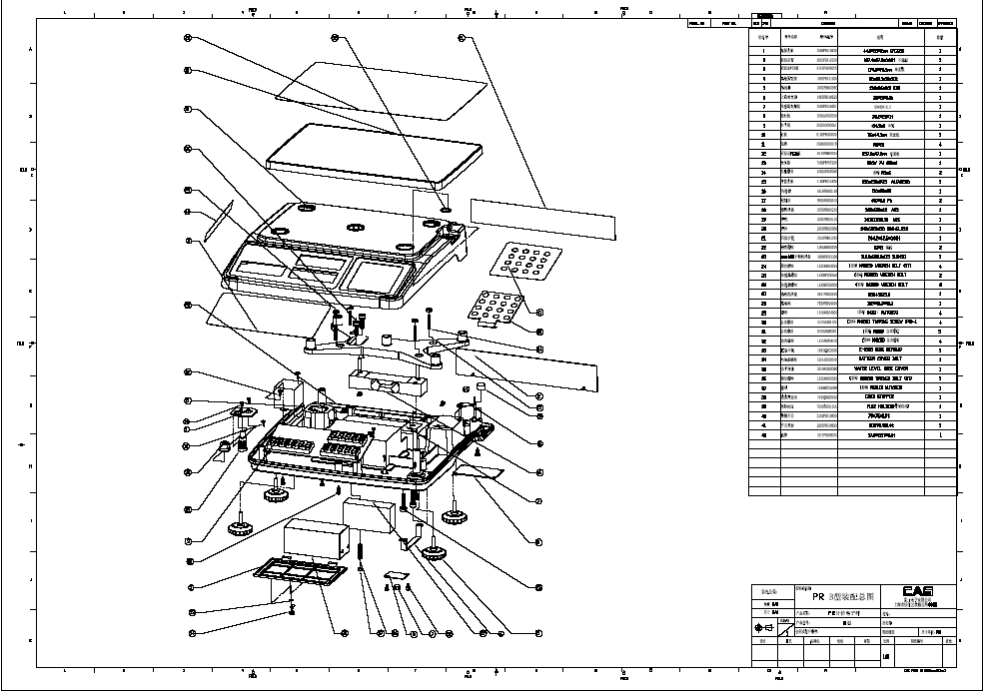
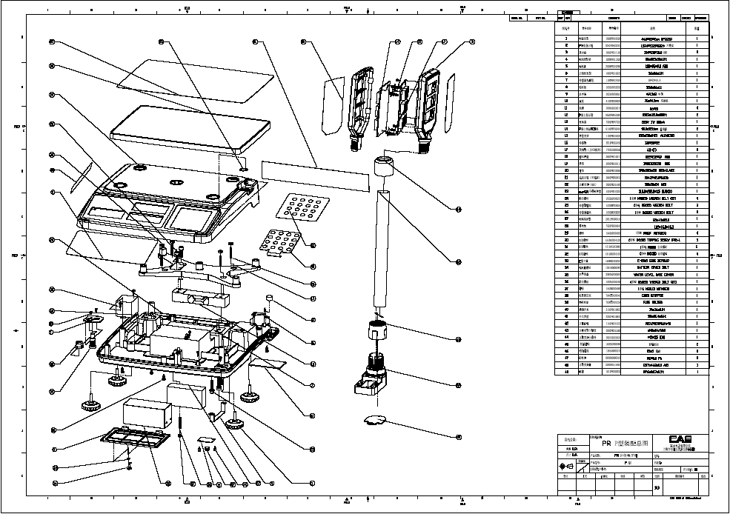

5、Part Location

5.1 Main PCB (Top)
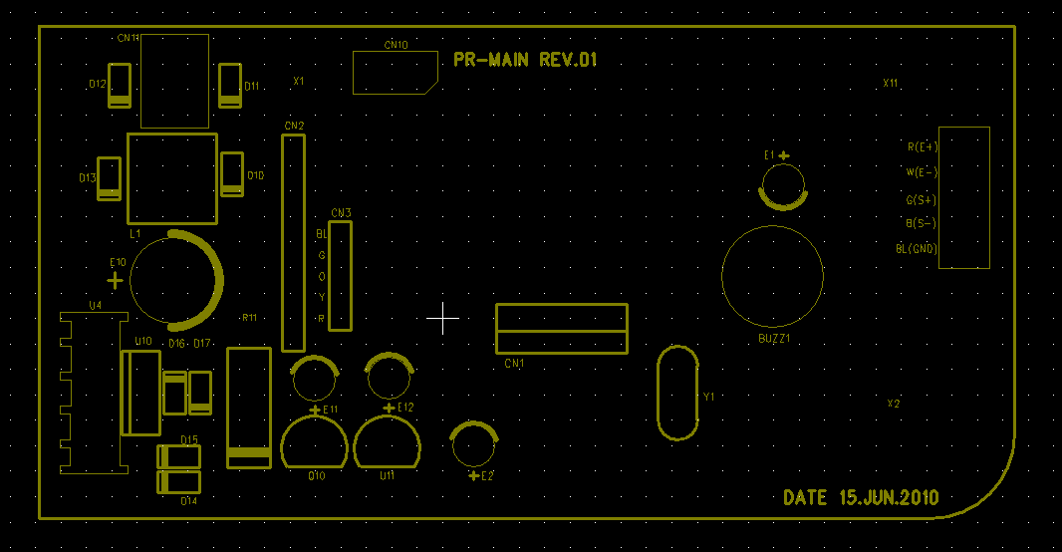

5.2 Main PCB (Bottom)
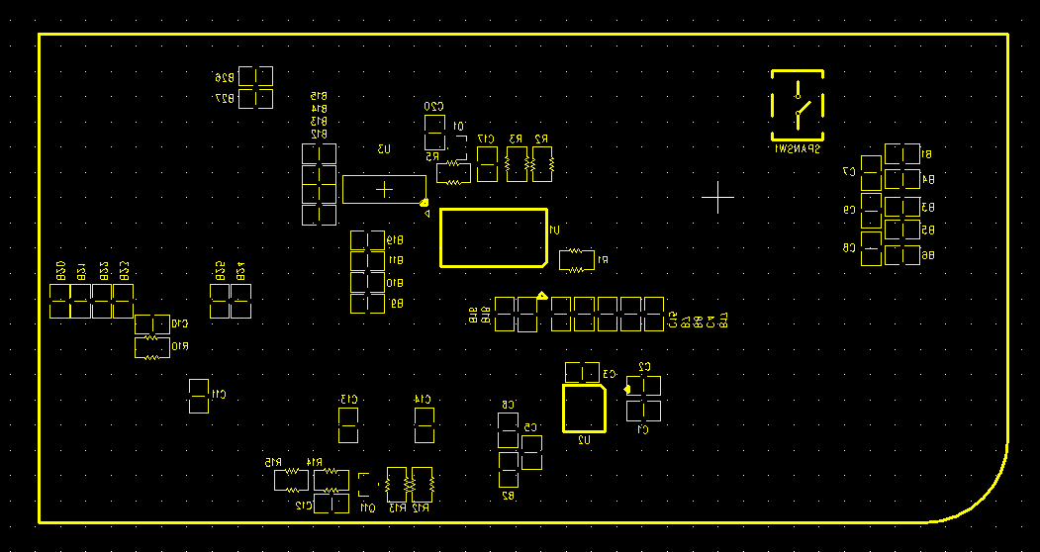

5.3 Pole Display PCB (Top)
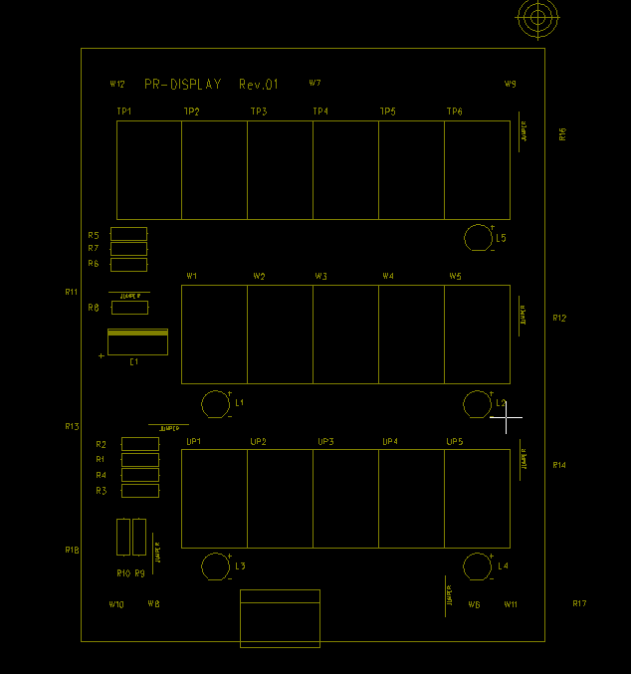

5.4 Pole Display PCB (Bottom)
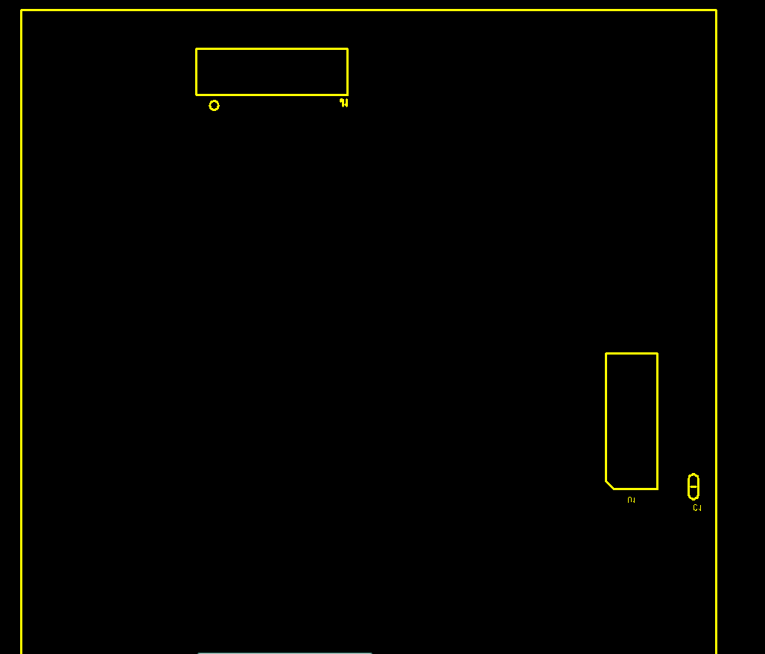

5.6 Bench Front Display PCB (Top)
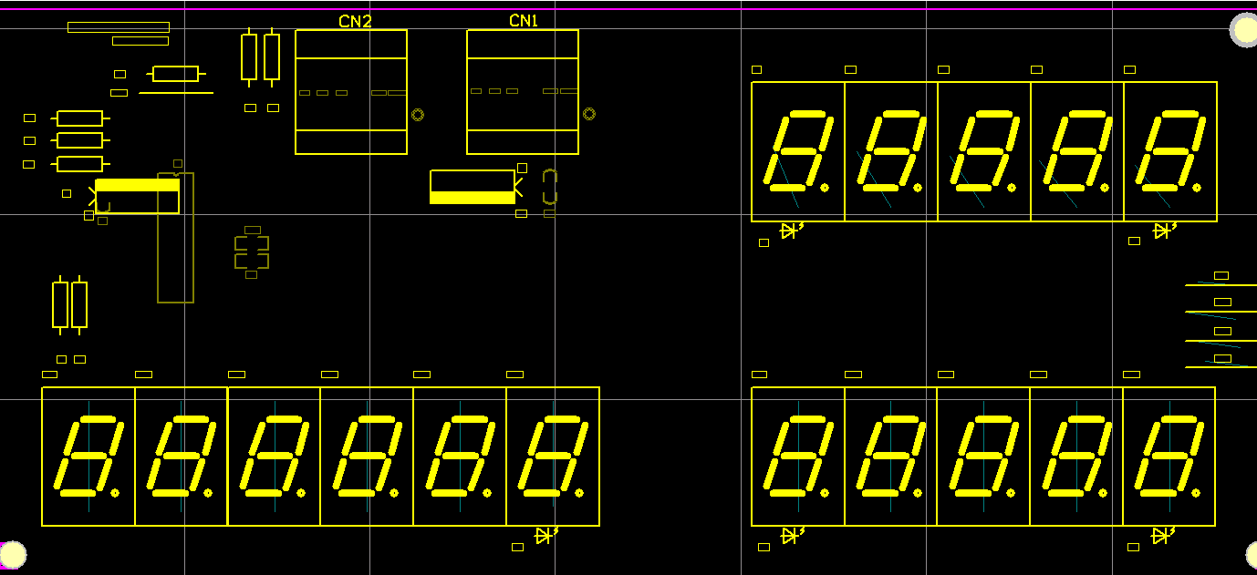

5.7 Bench Rear Display PCB (Top)
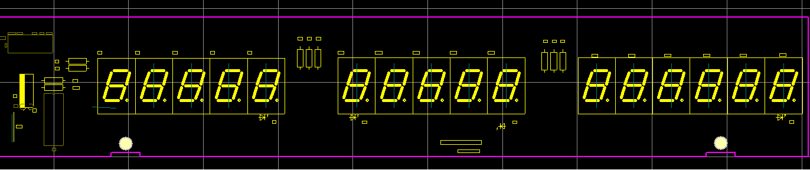

6、Part List
1.1 BODY ASS'Y
ASS'Y NAME | KOREA P/N | SPEC | QTY
PR | 9002PR000CN0 | MANUAL(China) | 1
BENCH BODY ASS'Y | 7502PPR02200 | 220V 7V 800mA | 1
BENCH BODY ASS'Y | 2000A0010000 | 340*335*150 ABS+GLASS | 1
BENCH BODY ASS'Y | 7520P0070000 | 102*46.3*46.3（4V/4A PB） | 1
BENCH BODY ASS'Y | 7840W0031100 | 3P*110/240MM | 1
BENCH BODY ASS'Y | 2022A0000050 | Φ14.5*8 CHINA | 1
BENCH BODY ASS'Y | 2631PR000010 | 85*45*25.8 | 1
BENCH BODY ASS'Y | 1000A0010000 | 36*20*1.0 | 1
BENCH BODY ASS'Y | 2000A0010010 | 138*96*9.3 ABS | 1
POLE BODY ASS'Y | 1261A0000040 | M4*0.7*8.5(SUS)TP | 1
POLE BODY ASS'Y | 1561MSU03000 | Φ3*Φ7*0.6 | 1
BENCH BODY ASS'Y | 1000A0010010 | 44.8*39*2MM | 1
BENCH BODY ASS'Y | 1261A0000040 | BATTERY COVER BOLT | 1
BENCH BODY ASS'Y | 1000A0010020 | 90*20.5*10*1.0T | 1
BENCH BODY ASS'Y | 2008A000001B | M6*20 RUBBER | 4
BENCH BODY ASS'Y | 1502A0003080 | M3*8 | 2
BENCH BODY ASS'Y | 1510A0004120 | M4*12 | 10
BENCH BODY ASS'Y | 1532A0006250 | M6*25 彩锌(STOPPER) | 1
BENCH BODY ASS'Y | 1510A0004120 | M4*8 | 7
BENCH BODY ASS'Y | 1502A0003080 | M4*8 | 1
BENCH BODY ASS'Y | 1510A0004120 | M3*8 | 3
BENCH BODY ASS'Y | 7840W0062000 | 6P*200 | 1
BENCH BODY ASS'Y | 7560PAC00410 | CHINA 2m 250v 10A | 1
BENCH BODY ASS'Y | 7630S0000030 | 3P-0717(INLET,FUSE) CHINA | 1
BENCH BODY ASS'Y | 7620S0605000 | 0.5A/250V Ф6 UL,CSA(SP-LED) | 1
BENCH BODY ASS'Y | 7642S0000600 | 51*25*1.5mm 6N | 3
BENCH BODY ASS'Y | 7640S0005050 |  | 1
BENCH BODY ASS'Y | 765030000200 |  | 5
BENCH BODY ASS'Y | 1530A0006250 | M6*25 | 2
BENCH BODY ASS'Y | 1551A0006300 | Φ6.3 | 2
1.2BENCH UPPER CASE ASS'Y
BENCH UPPER CASE ASS'Y | 2000A0010020 | 340*335*150 ABS | 1
BENCH UPPER CASE ASS'Y | 2050PRA06330 | 195.85*92.7*0.5 | 1
BENCH UPPER CASE ASS'Y | 2050PRB06330 | 263.4*42.5*0.5 | 1
BENCH UPPER CASE ASS'Y | 2010A0000260 | Φ18.5*0.5t | 1
BENCH UPPER CASE ASS'Y | 2200PR000330 | KEY CIRCUIT | 1
BENCH UPPER CASE ASS'Y | 2200PR000CN0 | KEYSHEET | 1
BENCH UPPER CASE ASS'Y | 1800PR000000 | 97.6*22.7*0.5t | 1
1.3TRAY ASS'Y
TRAY ASS'Y | 2000A0010030 | 322*212*13 ABS | 1
TRAY ASS'Y | 1000PR010030 | 313.8*202.8*0.5 SUS430 | 1
TRAY ASS'Y | 2632A0010000 |  | 1
1.4L/C BRACKET ASS'Y
L/C BRACKET ASS'Y | 1100A0010000 | 250*150*29.5 AL(ADC12) | 1
L/C BRACKET ASS'Y | 1532A0006250 | M4*25 黑色 | 4
L/C BRACKET ASS'Y | 1540A0004000 | M4*3 | 4
L/C BRACKET ASS'Y | 5500PR000600 | 130*30*22 | 1
L/C BRACKET ASS'Y | 1530A0006250 | M6*20 | 2
L/C BRACKET ASS'Y | 1551A0006300 | Φ6.3 | 2
1.5BENCH C/T BOX ASS'Y
BENCH C/T BOX ASS'Y | 9203PR000010 | B 型 | 1
BENCH C/T BOX ASS'Y | 9203PR000020 | B 型 | 1
BENCH C/T BOX ASS'Y | 9103PR000010 | B 型 | 1
BENCH C/T BOX ASS'Y | 1030A0002030 | 35.2*26*1t | 1
BENCH C/T BOX ASS'Y | 1265A0000010 | M3*5 | 2
BENCH C/T BOX ASS'Y | 9900A0000010 | Φ10*5.6 | 2
BENCH C/T BOX ASS'Y | 9304A000005B |  | 1
1.6MAIN PCB ASSY
MAIN PCB ASSY | 6100PPR00000 | 76*44.5mm 양면 | 1
MAIN PCB ASSY | 6200ISO08250 | N79E825 | 1
MAIN PCB ASSY | 6214IS011800 | CS1180 | 1
MAIN PCB ASSY | 6220I0078050 | LM7805 | 1
MAIN PCB ASSY | 6236IS001380 | 74HC138(LP-Ⅱ) | 1
MAIN PCB ASSY | 1050A0002200 | TO-220 STANDUP | 1
MAIN PCB ASSY | 6220I0078050 | 7330 | 1
MAIN PCB ASSY | 6280I0090150 | 9015 | 1
MAIN PCB ASSY | 6280I0090150 | 9014 | 1
MAIN PCB ASSY | 6280I0090150 | 2SA1020 | 1
MAIN PCB ASSY | 6670T0001020 | HB-1M201102JT(TP2,LP2,DBB) | 27
MAIN PCB ASSY | 6527IF310000 | FTR 0805 104(100k)（1%） | 1
MAIN PCB ASSY | 6527IF310000 | RR1220P-103D(10K)（1%） | 2
MAIN PCB ASSY | 6527IF310000 | FTR 0805 102(1k)（1%） | 2
MAIN PCB ASSY | 6527IF310000 | FTR 0805 105(1M)（1%） | 2
MAIN PCB ASSY | 6527IF310000 | FTR 0805 203(20K)（1%） | 1
MAIN PCB ASSY | 6527IF310000 | FTR 0805 202(2K)（1%） | 1
MAIN PCB ASSY | 6512CJ000100 | CFR 1ohm/ 2W | 1
MAIN PCB ASSY | 6712CHP01040 | CL21C 104KBNC | 12
MAIN PCB ASSY | 6712CHP01040 | CL21C 200JBNC (20PF) | 2
MAIN PCB ASSY | 6704C1001000 | 100UF/16V | 2
MAIN PCB ASSY | 6704C1001000 | 10UF/16V | 1
MAIN PCB ASSY | 6804F0010040 | LINE FILTER | 1
MAIN PCB ASSY | 6704C1001000 | 1000UF/25V | 1
MAIN PCB ASSY | 6291IP040040 | 1N4004 | 6
MAIN PCB ASSY | 6294ISW41480 | 1N4148（DIP） | 2
MAIN PCB ASSY | 7010ZM049150 | 4.9152MHz (ATS-49U/S) | 1
MAIN PCB ASSY | 7600STA19020 | 11902(DJTA-1102) | 1
MAIN PCB ASSY | 7002Z0000000 | APR,ADR(CHINA) | 1
MAIN PCB ASSY | 7801CLW00060 | LW0640-06 (LPH01-06) | 1
MAIN PCB ASSY | 7801CLW00060 | 5273-02 (LPH03-02) | 1
MAIN PCB ASSY | 7801CLW00060 | 03-5267 | 1
MAIN PCB ASSY | 7801CLW00060 | 2.54*18mm*40PIN （5PIN ） | 0.38
1.7BENCH FRONT DISP ASS
BENCH FRONT DISP ASSY | 6110PPR00000 | 174.8*78.9mm단면 | 1
BENCH FRONT DISP ASSY | 6224I0058170 | CS5817 | 1
BENCH FRONT DISP ASSY | 6712CHP01040 | CL21C 104KBNC | 1
BENCH FRONT DISP ASSY | 6704C1001000 | 100UF/16V | 2
BENCH FRONT DISP ASSY | 6505MF015000 | MF--25T1/4W 150ohm（1%） | 10
BENCH FRONT DISP ASSY | 6527IF310000 | FTR 0805 102(1k)（1%） | 2
BENCH FRONT DISP ASSY | 7230D0051610 | JX5161AH | 16
BENCH FRONT DISP ASSY | 7232DR00003A | Ф3-RED 红 | 5
BENCH FRONT DISP ASSY | 7801CLW00060 | LA0640-06 (LPHA01-06) | 2
BENCH FRONT DISP ASSY | 7844W0001000 | Ф0.6 * 10m/m | 7
1.8BENCH REAR DISP ASSY
BENCH REAR DISP ASSY | 6110PRB00014 | 257.3*47.9mm 单面板 | 1
BENCH REAR DISP ASSY | 6505MF015000 | MF--25T1/4W 150ohm（1%） | 8
BENCH REAR DISP ASSY | 7230D0051610 | JX5161AH | 16
BENCH REAR DISP ASSY | 7232DR00003A | Ф3-RED 红 | 4
BENCH REAR DISP ASSY | 7840W0PR0450 | 6P*450 | 1
BENCH REAR DISP ASSY | 6224I0058170 | CS5817 | 1
BENCH REAR DISP ASSY | 6712CHP01040 | CL21C 104KBNC | 1
BENCH REAR DISP ASSY | 6704C1001000 | 100UF/16V | 1

 | 1.1 POLE BODY ASS'Y
 | ASS'Y NAME | NUMBER |  |  | NAME | QTY
 | PR | 9002PR011620 |  |  | MANUAL CHINA | 1
 | POLE BODY ASS'Y | 7502PRP070220 |  |  | TRANSFORMOR 220V 7V 800mA | 1
 | POLE BODY ASS'Y | 2000PR010060 |  |  | BODY 340*335*150 ABS+GLASS | 1
 | POLE BODY ASS'Y | 7520PR004040 |  |  | BATTERY 102*46.3*46.3 | 1
 | POLE BODY ASS'Y | 7840W00A2220 |  |  | BATTER WIRE 3P*110/240MM | 1
 | POLE BODY ASS'Y | 2022A0000051 |  |  | WATER LEVEL GAGE Φ14.5*8 CHINA | 1
 | POLE BODY ASS'Y | 2631PR000010 |  |  | BATTERY CUSHION 85*45*25.8 | 1
 | POLE BODY ASS'Y | 1000PR010520 |  |  | BRACKET_SEALING 85*45*25.8 | 1
 | POLE BODY ASS'Y | 2000PR010960 |  |  | BATTERY-COVER138*96*9.3 ABS | 1
 | POLE BODY ASS'Y | 1261A0000040 |  |  | BOLT-BATTERY-COVER M4*0.7*8.5(SUS)TP | 1
 | POLE BODY ASS'Y | 1561MSU0300 |  |  | E-RING Φ3*Φ7*0.6 | 1
 | POLE BODY ASS'Y | 1000PR010620 |  |  | POWER BRACKET | 1
 | POLE BODY ASS'Y | 1000PR011020 |  |  | BATTERY HOLDER | 1
 | POLE BODY ASS'Y | 2008A000001B |  |  | FOOT M6*20 RUBBER | 4
 | POLE BODY ASS'Y | 1502A0003080 |  |  | MACHINE SCREW M3*8 | 2
 | POLE BODY ASS'Y | 1510A00004120 |  |  | TAPPING SCREW (PH) M4*12 | 10
 | POLE BODY ASS'Y | 1532A0006250 |  |  | BOLT WRENCH (ST) M6*25 彩锌 | 1
 | POLE BODY ASS'Y | 1510A0004080 |  |  | TAPPING SCREW (PH) M4*8 | 7
 | POLE BODY ASS'Y | 1502A0004080 |  |  | MACHINE SCREW M4*8 | 1
 | POLE BODY ASS'Y | 1510A0003080 |  |  | TAPPING SCREW (PH) M3*8 | 7
 | POLE BODY ASS'Y | 7560PAC00410 |  |  | AC CORD CHINA 2m 250v 10A | 1
 | POLE BODY ASS'Y | 7630S0000030 |  |  | 3P-0717(INLET,FUSE) CHINA | 1
 | POLE BODY ASS'Y | 7620S0605000 |  |  | FUSE 250V 500mA | 1
 | POLE BODY ASS'Y | 7642S0000600 |  |  | METAL CLAMP | 3
 | POLE BODY ASS'Y | 7640S0005050 |  |  | CORD STOPPER | 1
 | POLE BODY ASS'Y | 765030000200 |  |  | TIE BAND | 5
 | POLE BODY ASS'Y | 1530MPZ06250 |  |  | BOLT WRENCH M6*25 | 2
 | POLE BODY ASS'Y | 1551MPZ06000 |  |  | WASHER (SPR M6) Φ6.3 | 2
 | POLE BODY ASS'Y | 7702G0000040 |  |  | PCB CONNECTOR | 3
 | 1.2 POLE UPPER CASE ASS'Y
 | POLE UPPER CASE ASS'Y | 2000PR010110 |  |  | CASE 340*335*150 ABS | 1
 | POLE UPPER CASE ASS'Y | 2050PRA00330 |  |  | OP_DISP_PC 195.85*92.7*0.5 | 1
 | POLE UPPER CASE ASS'Y | 2050PRB00330 |  |  | CUST_DISP 263.4*42.5*0.5 | 1
 | POLE UPPER CASE ASS'Y | 2010A0000260 |  |  | LEVEL COVER Φ18.5*0.5t | 1
 | POLE UPPER CASE ASS'Y | 2100PR010820 |  |  | MEMBERSWITCH KEY | 1
 | POLE UPPER CASE ASS'Y | 2200PR010820 |  |  | MEMBERSWITCH KEYSHEET | 1
 | POLE UPPER CASE ASS'Y | 1800PR012100 |  |  | NAME PLATE 97.6*22.7*0.5t | 1
 | 1.3 TRAY ASS'Y
 | TRAY ASS'Y | 2000PR010210 |  |  | TRAY(ABS) 322*212*13 | 1
 | TRAY ASS'Y | 1000PR010320 |  |  | PLATTER 313.8*202.8*0.5 SUS430 | 1
 | TRAY ASS'Y | 8700PR012000 |  |  | Double Faced Adhesive Tape | 0.083
 | 1.4 L/C BRACKET ASS'Y
 | L/C BRACKET ASS'Y | 1100PR010420 |  |  | TRAY SUPPORT250*150*29.5 AL | 1
 | L/C BRACKET ASS'Y | 1532A0004250 |  |  | BOLT WRENCH (ST) M4*25 | 4
 | L/C BRACKET ASS'Y | 1540A0004000 |  |  | NUT (HEX) M4*3 | 4
 | L/C BRACKET ASS'Y | 5519PR000300 |  |  | LOADCELL 130*30*22 | 1
 | L/C BRACKET ASS'Y | 1530MPZ06200 |  |  | BOLT WRENCH M6*20 | 2
 | L/C BRACKET ASS'Y | 1551MPZ06000 |  |  | WASHER (SPR M6) Φ6.3 | 2
 | 1.5 POLE DISP CASE ASS'Y
 | POLE DISP CASE ASS'Y | 2000PR011180 |  |  | DISPLAY-CASE | 2
 | POLE DISP CASE ASS'Y | 2055PRA06330 |  |  | DISPLAY-COVER 135*111.25*1.0 | 2
 | POLE DISP CASE ASS'Y | 1150PR011220 |  |  | PIPE Φ27.2*270 AL | 1
 | POLE DISP CASE ASS'Y | 2001A0000420 |  |  | DISPLAY NUTΦ43*35 ABS | 1
 | POLE DISP CASE ASS'Y | 2000PR011380 |  |  | POLE_BASE3_CAPΦ42*34 ABS | 1
 | POLE DISP CASE ASS'Y | 2000PR011480 |  |  | POLE_BASE 100*50*54 ABS | 1
 | POLE DISP CASE ASS'Y | 2020PR011580 |  |  | PR POLE CONNECTOR | 1
 | POLE DISP CASE ASS'Y | 7840W0PR1000 |  |  | WIRE 6P*1000 | 1
 | POLE DISP CASE ASS'Y | 7702G0000040 |  |  | PCB SUPPORT 4N-(T) | 3
 | 1.6POLE C/T BOX ASS'Y
 | POLE C/T BOX ASS'Y | 9204PR011780 |  |  | STYROFOAM BOX | 1
 | POLE C/T BOX ASS'Y | 9204PR011880 |  |  | STYROFOAM BOX | 1
 | POLE C/T BOX ASS'Y | 9104PR011980 |  |  | C/T BOX | 1
 | POLE C/T BOX ASS'Y | 1030A0002030 |  |  | SEALING PLATE 35.2*26*1t | 1
 | POLE C/T BOX ASS'Y | 1265A0000010 |  |  | SEALING_BOLT M3*5 | 2
 | POLE C/T BOX ASS'Y | 9900A0000010 |  |  | SEALING PB Φ10*5.6 | 2
 | POLE C/T BOX ASS'Y | 9304A000005B |  |  | POLY BAG | 1
 | POLE C/T BOX ASS'Y | 9304A000001A |  |  | POLY BAG(DISPLAY) | 1
 | 1.6MAIN PCB ASSY
 | MAIN PCB ASSY | 6100PPR00000 |  |  | 76*44.5mm 양면 | 1
 | MAIN PCB ASSY | 6200ISO08250 |  |  | N79E825 | 1
 | MAIN PCB ASSY | 6214IS011800 |  |  | CS1180 | 1
 | MAIN PCB ASSY | 6220I0078050 |  |  | LM7805 | 1
MAIN PCB ASSY |  | 6236IS001380 |  |  | 74HC138(LP-Ⅱ) | 1
 | MAIN PCB ASSY | 1050A0002200 |  |  | TO-220 STANDUP | 1
 | MAIN PCB ASSY | 6220I0078050 |  |  | 7330 | 1
 | MAIN PCB ASSY | 6280I0090150 |  |  | 9015 | 1
 | MAIN PCB ASSY | 6280I0090150 |  |  | 9014 | 1
 | MAIN PCB ASSY | 6280I0090150 |  |  | 2SA1020 | 1
 | MAIN PCB ASSY | 6670T0001020 |  |  | HB-1M201102JT(TP2,LP2,DBB) | 27
 | MAIN PCB ASSY | 6527IF310000 |  |  | FTR 0805 104(100k)（1%） | 1
 | MAIN PCB ASSY | 6527IF310000 |  |  | RR1220P-103D(10K)（1%） | 2
 | MAIN PCB ASSY | 6527IF310000 |  |  | FTR 0805 102(1k)（1%） | 2
 | MAIN PCB ASSY | 6527IF310000 |  |  | FTR 0805 105(1M)（1%） | 2
 | MAIN PCB ASSY | 6527IF310000 |  |  | FTR 0805 203(20K)（1%） | 1
 | MAIN PCB ASSY | 6527IF310000 |  |  | FTR 0805 202(2K)（1%） | 1
 | MAIN PCB ASSY | 6512CJ000100 |  |  | CFR 1ohm/ 2W | 1
 | MAIN PCB ASSY | 6712CHP01040 |  |  | CL21C 104KBNC | 12
 | MAIN PCB ASSY | 6712CHP01040 |  |  | CL21C 200JBNC (20PF) | 2
 | MAIN PCB ASSY | 6704C1001000 |  |  | 100UF/16V | 2
 | MAIN PCB ASSY | 6704C1001000 |  |  | 10UF/16V | 1
 | MAIN PCB ASSY | 6804F0010040 |  |  | LINE FILTER | 1
 | MAIN PCB ASSY | 6704C1001000 |  |  | 1000UF/25V | 1
 | MAIN PCB ASSY | 6291IP040040 |  |  | 1N4004 | 6
 | MAIN PCB ASSY | 6294ISW41480 |  |  | 1N4148（DIP） | 2
 | MAIN PCB ASSY | 7010ZM049150 |  |  | 4.9152MHz (ATS-49U/S) | 1
 | MAIN PCB ASSY | 7600STA19020 |  |  | 11902(DJTA-1102) | 1
 | MAIN PCB ASSY | 7002Z0000000 |  |  | APR,ADR(CHINA) | 1
 | MAIN PCB ASSY | 7801CLW00060 |  |  | LW0640-06 (LPH01-06) | 1
 | MAIN PCB ASSY | 7801CLW00060 |  |  | 5273-02 (LPH03-02) | 1
 | MAIN PCB ASSY | 7801CLW00060 |  |  | 03-5267 | 1
 | MAIN PCB ASSY | 7801CLW00060 |  |  | 2.54*18mm*40PIN （5PIN ） | 0.38
1.8POLE DISP ASSY
POLE DISP ASSY |  |  | 6110PRP00001 |  | 6110-PRP-0000-1 | 2
POLE DISP ASSY |  |  | 6224I0058170 |  | CS5817 | 2
POLE DISP ASSY |  |  | 6712CHP01040 |  | CL21C 104KBNC | 2
POLE DISP ASSY |  |  | 6704C1601000 |  | 100UF/16V | 2
POLE DISP ASSY |  |  | 6505MF015000 |  | MF--25T1/4W 150ohm（1%） | 20
POLE DISP ASSY |  |  | 7230D0005161 |  | JX5161AH | 32
POLE DISP ASSY |  |  | 7232DR00003A |  | Ф3-RED 红 | 10
POLE DISP ASSY |  |  | 7803CLA00060 |  | 6pin | 1
POLE DISP ASSY |  |  | 7844W0001000 |  | Ф0.6 * 10m/m | 4
POLE DISP ASSY |  |  | 7840W0PR0080 |  | 6P*80 | 1

