Seetech
GTOTAL Ver 3.0.0
[M150 + 175FF]
2016-02-16

* Release Note*
CD-Key for M175FF is developed like M150.

*How to use GTOTAL Ver 3.0.0
1. Unzip GTOTAL_Ver_3.0.0_M150_M175FF_20160216.zip
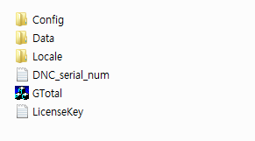
DNC_serial_num.txt - This file is for CD-Key of M150.
LicenseKey.txt - This file is for CD-Key of M175FF (2CIS)
2. Before execute GTotal.exe, you need to copy and paste CD-Key of M175FF to LicenseKey.txt
3. Execute GTOTAL Ver 3.0.0.
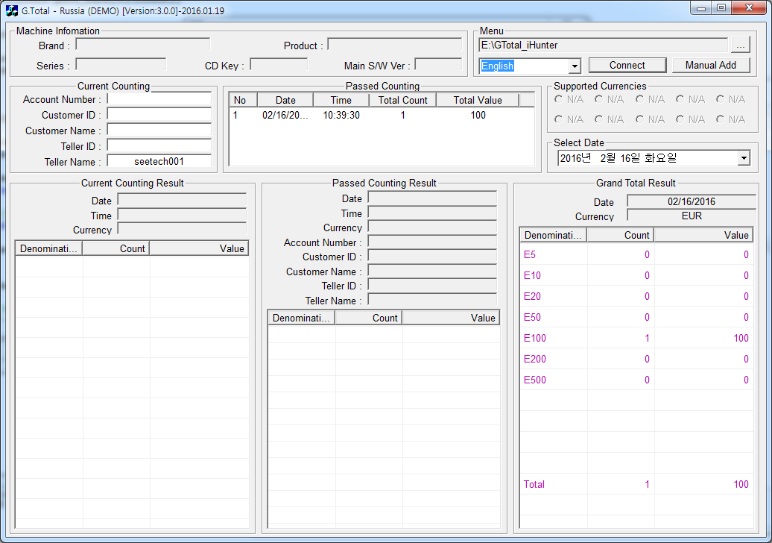

4. Click “Connect” button and Connect Setting Window is shown.
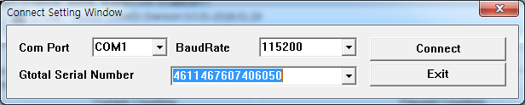

5. Select CD-Key and click “Connect” button again.
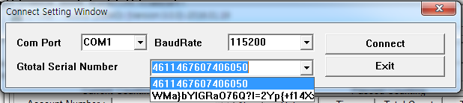

6. If the connection is OK, Machine Information is shown.
