Seetech
GTOTAL Ver 3.0.3
[M150 + 175FF(2CIS)+175(1CIS)]
2016-12-22

* Release Note*
1. CD-Key for M175FF is developed like M150.
2. M175(1CIS) can be connected to GTOTAL program like M150 and M175FF.

*How to use GTOTAL Ver 3.0.3
1. Unzip GTOTAL_Ver 3.0.3_M150_M175FF_M175_20161202.zip
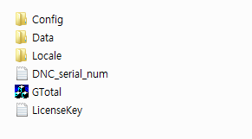
DNC_serial_num.txt - This file is for CD-Key of M150.
LicenseKey.txt - This file is for CD-Key of M175FF (2CIS) and M175(1CIS)
2. Before execute GTotal.exe, you need to copy and paste CD-Key of M175 to LicenseKey.txt
3. Execute GTOTAL Ver 3.0.3.
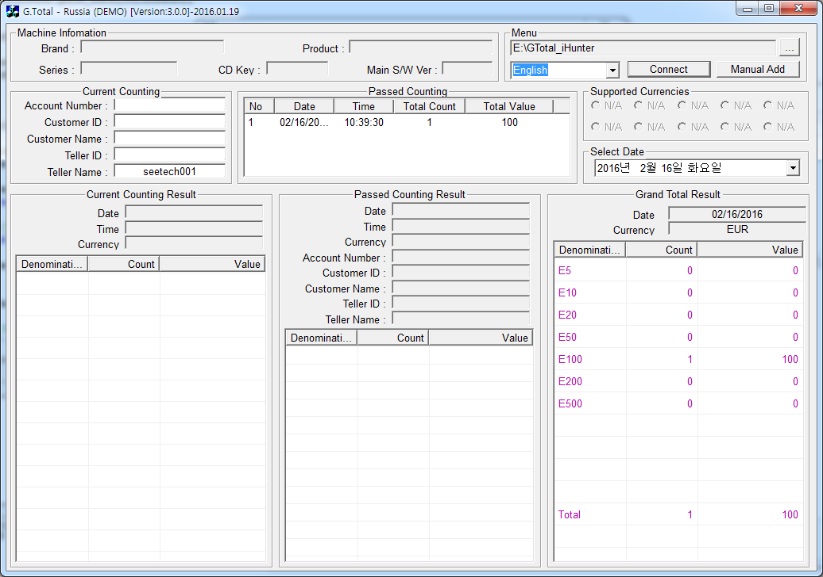

4. Click “Connect” button and Connect Setting Window is shown.
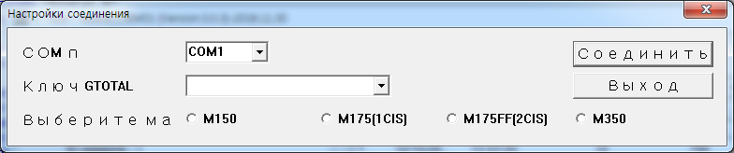
5. Select Connecting Machine first.

6. Select CD-Key and click “Connect” button again.
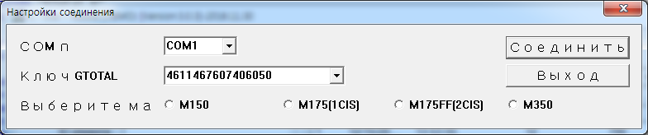

7. If the connection is OK, Machine Information is shown.
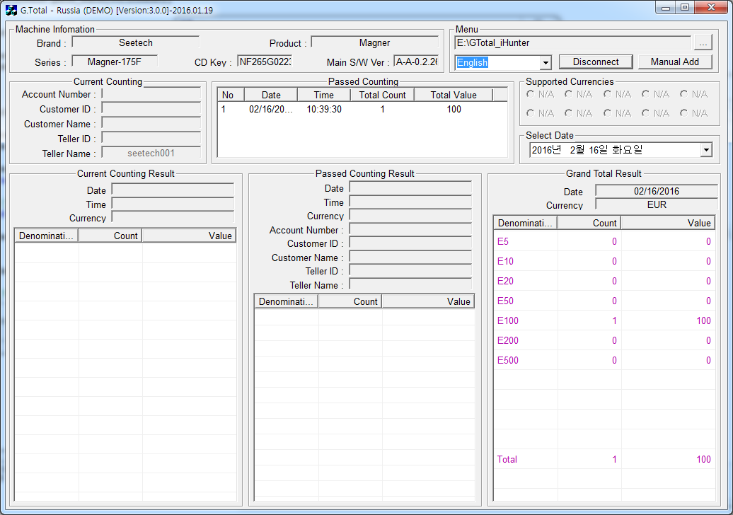

- How to connect each model to GTOTAL program
  - Click “Connection” button and Connect Setting Window is shown.
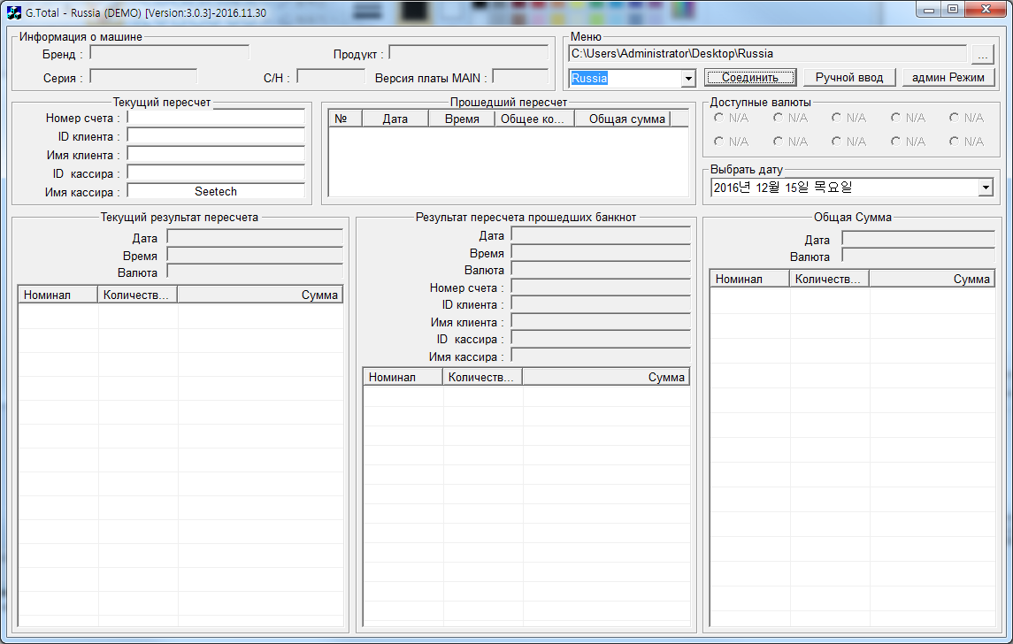
  - How to connect M150
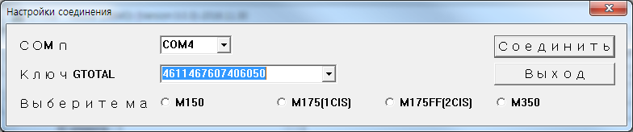
④
③
②
①
1) Select “Com Port”. (For example, [COM4])
2) Select “Gtotal Serial Number” which we supported.
3) Select “Connecting Machine - M150”.
4) Click “Connect” button
  - How to connect M175(1 CIS)
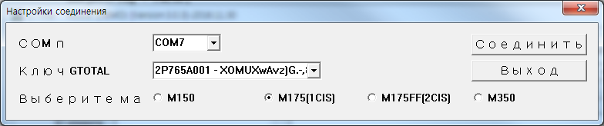
④
③
②
①
1) Select “Com Port”. (For example, [COM7])
2) Select “Gtotal Serial Number” which we supported.
3) Select “Connecting Machine - M175(1CIS)”.
4) Click “Connect” button
  - How to connect M175FF(2 CIS)
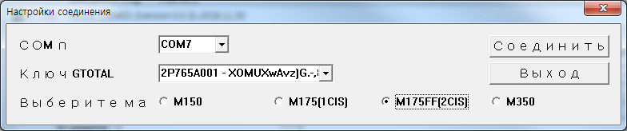
②
①
③
④
1) Select “Com Port”. (For example, [COM7])
2) Select “Gtotal Serial Number” which we supported.
3) Select “Connecting Machine - M175FF(2CIS)”.
4) Click “Connect” button
  - How to connect M1350
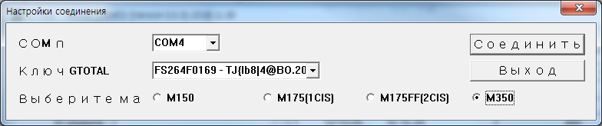
②
①
③
④
1) Select “Com Port”. (For example, [COM4])
2) Select “Gtotal Serial Number” which we supported.
3) Select “Connecting Machine - M350”.
4) Click “Connect” button
- How to add a new user to GTOTAL program
  - Execute GTOTAL Ver 3.0.3 and log-in window is shown as below.
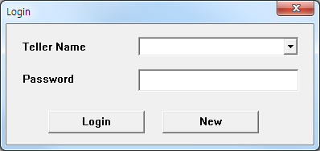
  - Click “New” button for adding a new user.
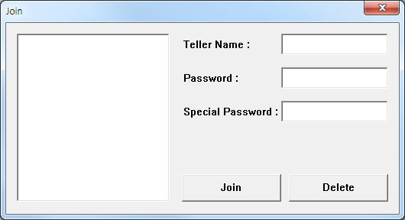
  - Enter Teller Name, Password and Special Password and Click “Join” for making the information for a new user.
Password is for log-in GTOTAL program and Special Password is for manual input and managing Excel files.
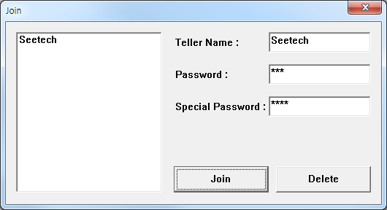
  - If you want to delete a user, click User ID and press “Delete” button.
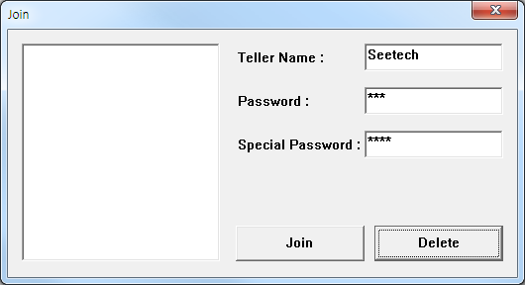
- How to connect GTOTAL program to each model
  - Click “Connection” button.
  - Select Comport.
  - Enter(or select) CD-Key (or License Key).
  - Select Model.
  - Click “Connect” button.

- How to use Manual ADD function from GTOTAL program
  - After connect the machine to GTOTAL program, count notes more than once.
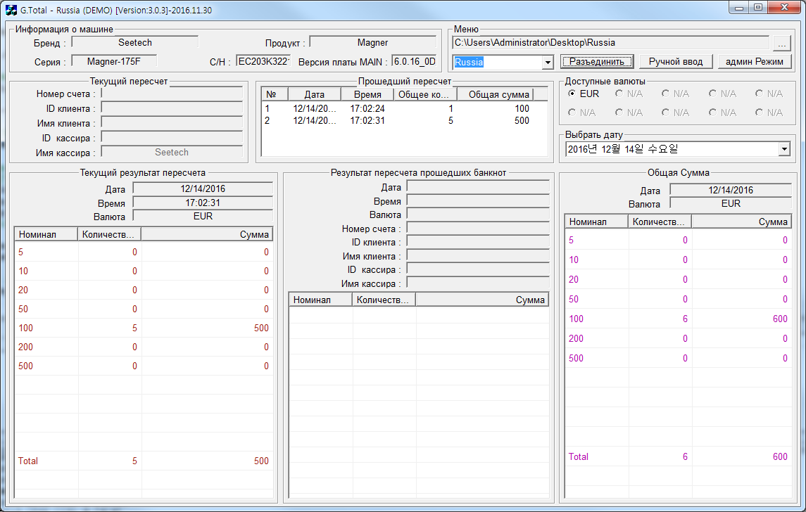
  - From Passed Counting list, click a list which you want to add counting result manually.
  - Click “Manual Add” button.
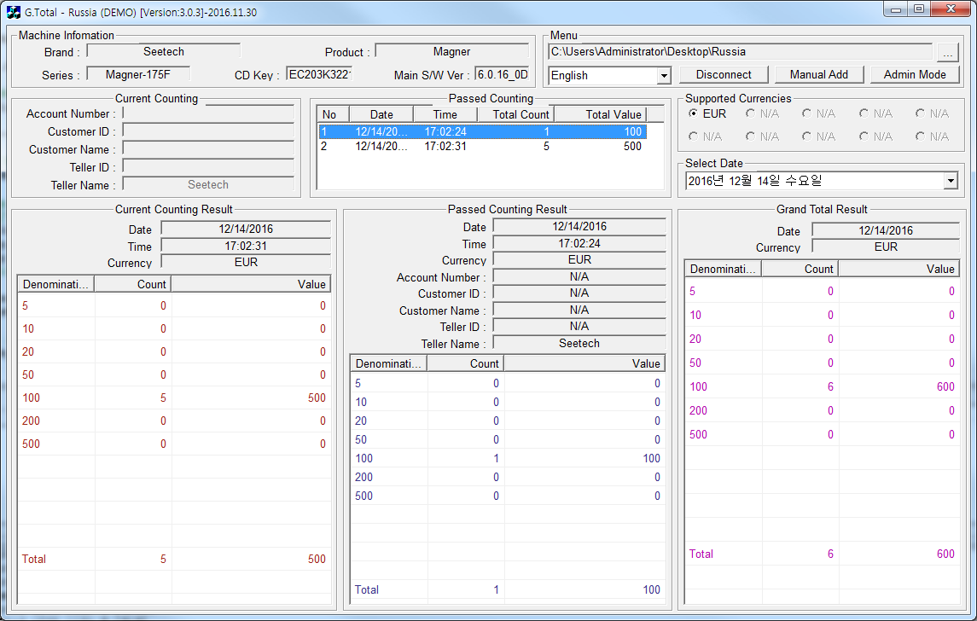

  - Password window is shown and enter Special Password.
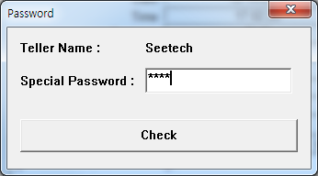
  - Manual Add window is shown as below.
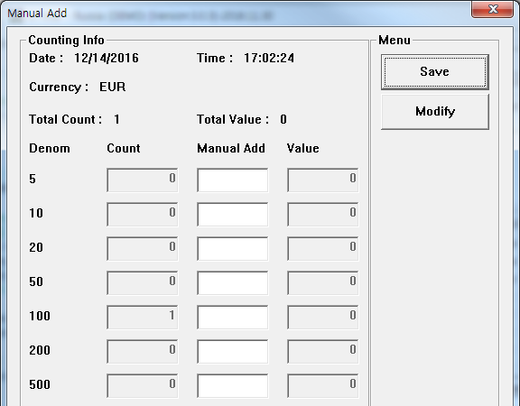

  - If you want to change the counting number, click “Modify” button.
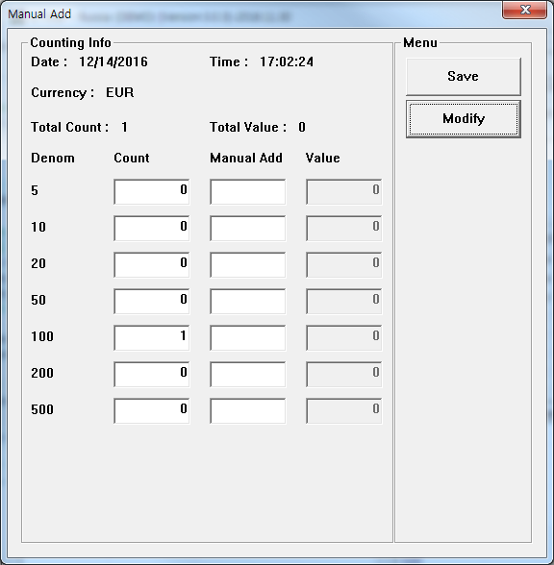
  - After changing or enter counting result, click “Save” button.
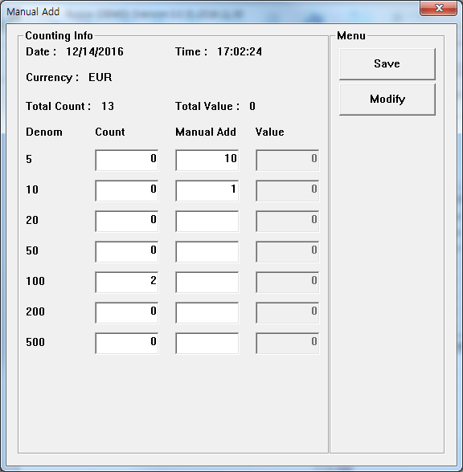

E. Check the changed result from Main screen of GTOTAL program.
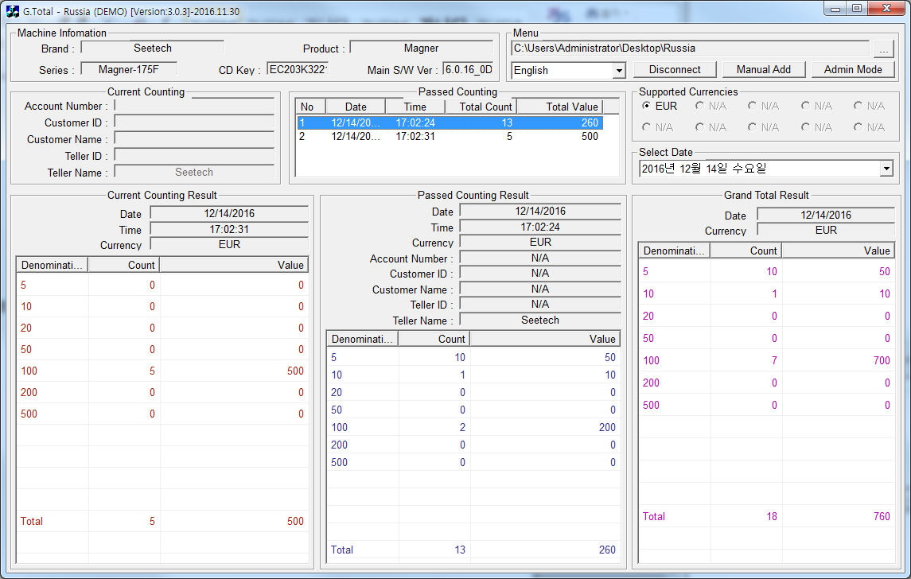

- How to use Admin Mode
  - Click “Admin Mode” button.

  - Password window is shown and enter Special Password.
  - Select folder which Excel file for each teller is saved.
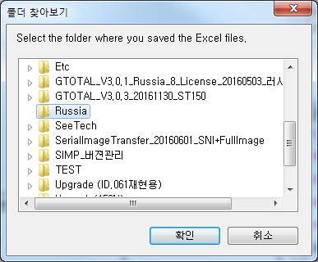
  - Excel files with Teller information and Counting result for each teller are shown as below.
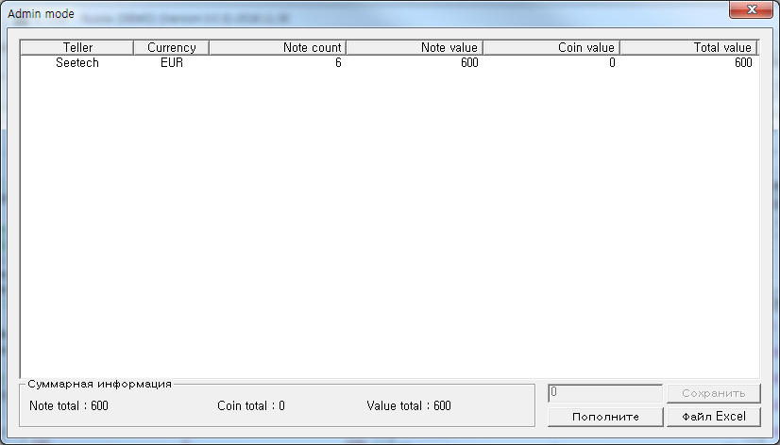
  - To enter Coin data, click “Manually coins add” button.
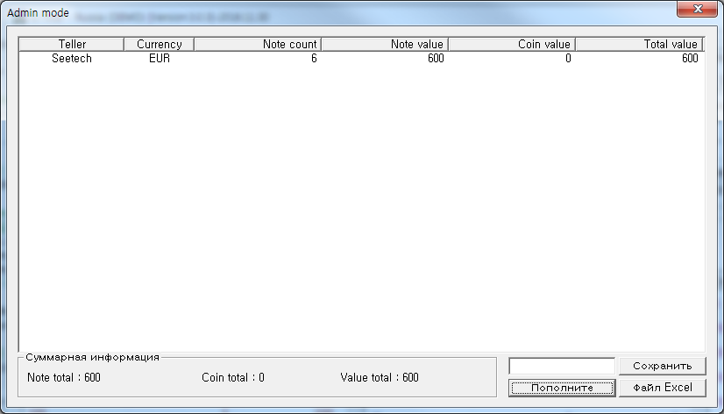
  - Select a excel file and enter Coin values.
  - After click “Save” button and check the added values on the screen.
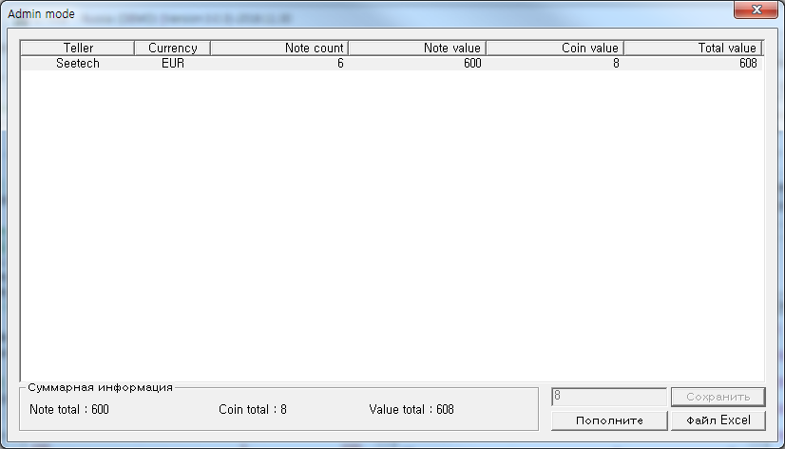

  - By clicking “Create Excel” button and you can make a combined Excel file about the excel files.
  - Open the combined Excel file.
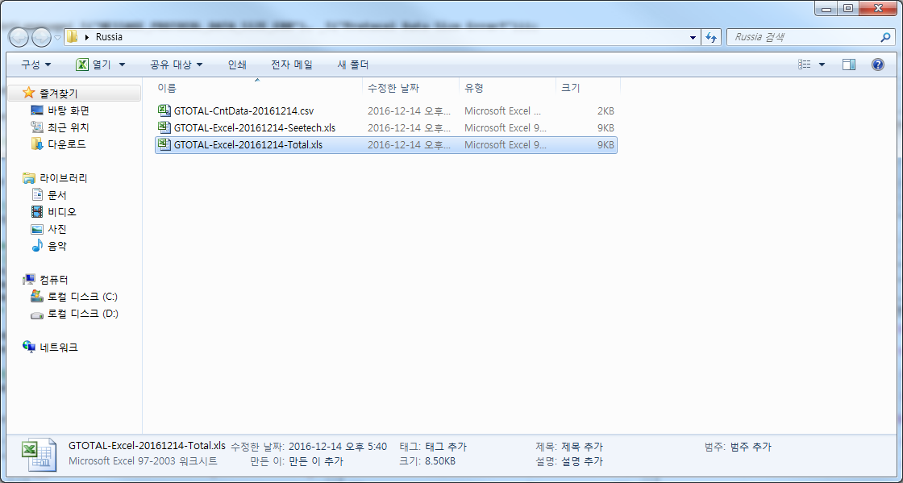
  - Check the combined data and added coin values.
