Assembly SOP of Side Board

Ⅰ Tools
3*150 cross screwdriver, 5.5# sleeve, 10#sleeve, 10#spanner

Ⅱ Disassembly
- Use cross screwdriver to take apart outer cover of the machine;
- Take down M6 nut by 10# sleeve;
- Take down the M5*12 hex head screw at the back of rail base，and weld the sensor cable on the AD board
Take down M6 nut by 10# sleeve, to disassemble storing hopper
Disassemble the hex head screw M5*10
- 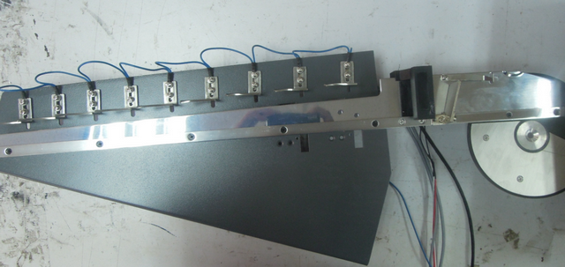
Take down hex head screw M5*12 by 8# sleeve.
Take down the rail base
- 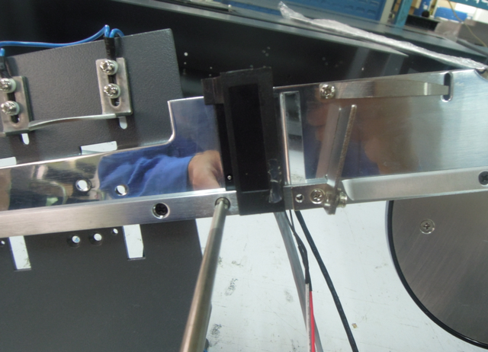
Loosen the stainless steel M3*8 by cross screwdriver.
- 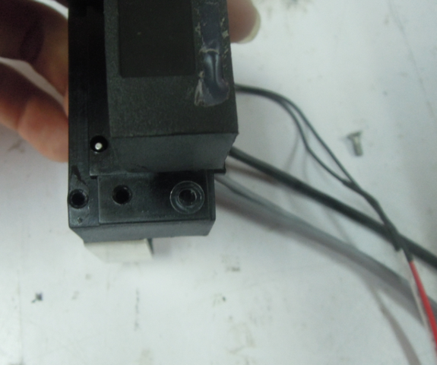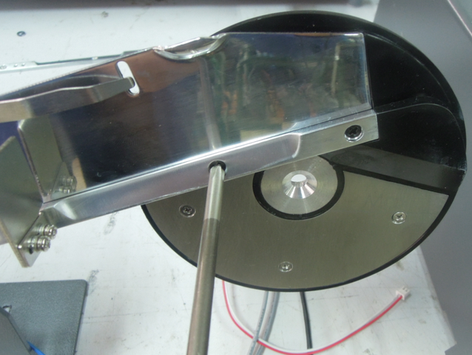
拆掉M3*10十字沉头螺钉
Note: don’t lose the washer 3*0.3
- 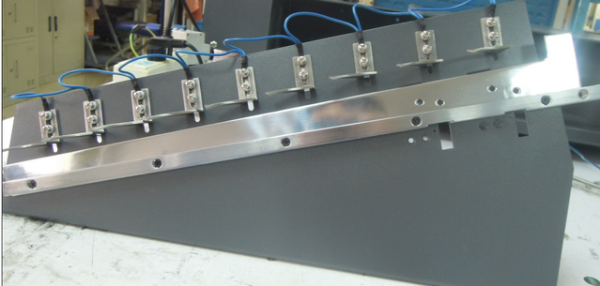
Take down the cross countersunk bolt M3*10

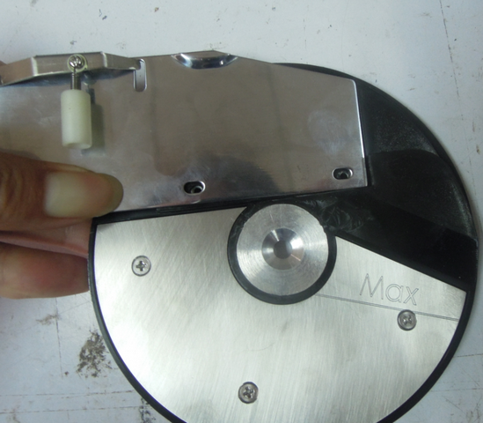
Ⅲ Assembly
Place the side board on Fixing disk, make sure there is no gap between each other.
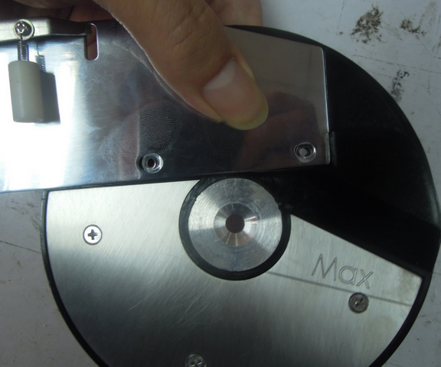
Place two washer 3*0.3 on the two holes.

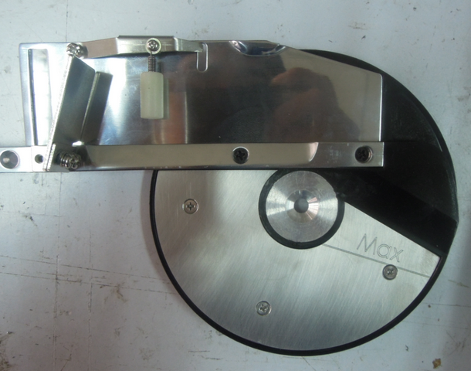
Use cross countersunk bolt M3*10 to fix left side board onto fixing plate
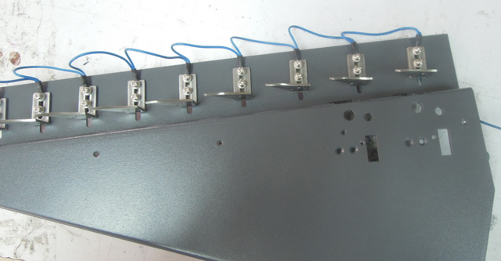
Place the rail base on the desk
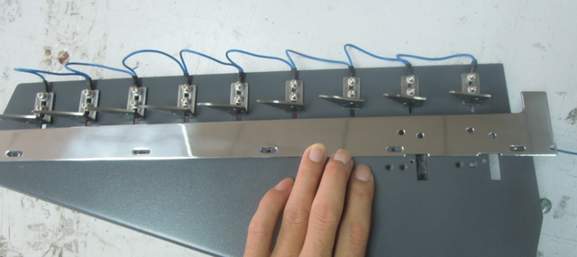
Make sure holes of right side board is aligned with those of rail base’s.
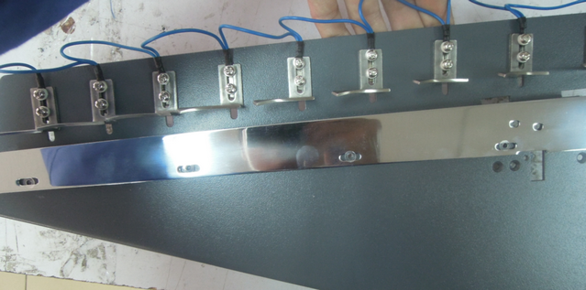
Put 3*0.3 washer on each hole
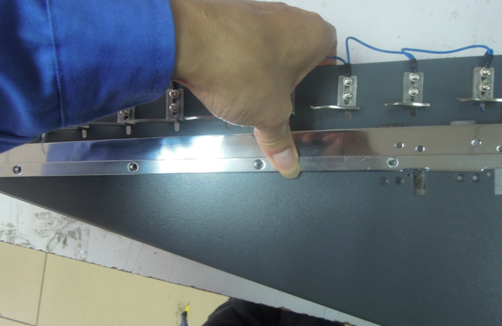
Assemble the Fixing disk on the rail base.
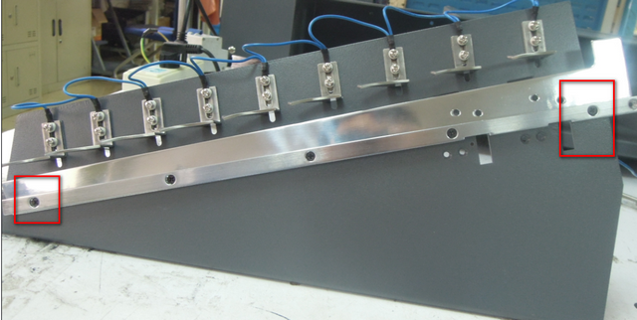
Lock the two bolts slightly, then lock the other screws one by one, but make sure no tightly lock.

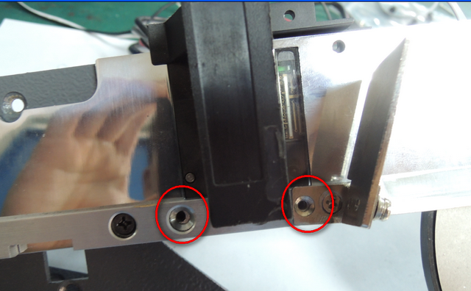
Put the CIS sensor on Right side board and left side board, and make sure the holes of side board and rail are parallel to each other(make sure there is washer 3*0.3 between side board and CIS sensor)

将装好CIS板子的传感器插到左右靠板上直到传感器孔与导轨孔能够对应上（注意在靠板、传感器平面与导轨之间有3*0.3垫圈）

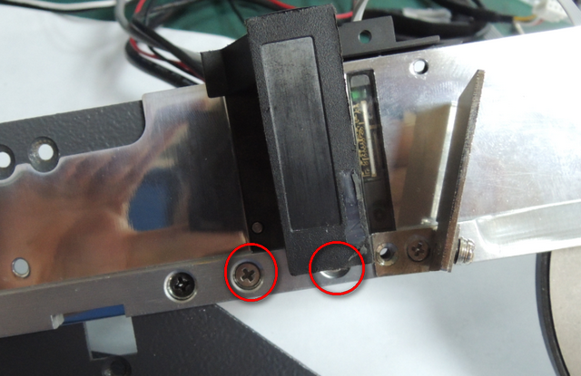
Use 2pcs Cross recessed countersunk head screw M4*8 to fix the CIS sensor, make sure right side board is higher than CIS sensor, and CIS sensor is higher than left board.
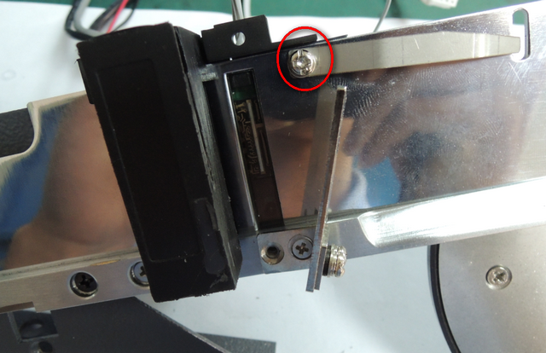
Use Composed cross recessed pan head screw M3*8 and nuts to lock the Coin separation plate on side board.

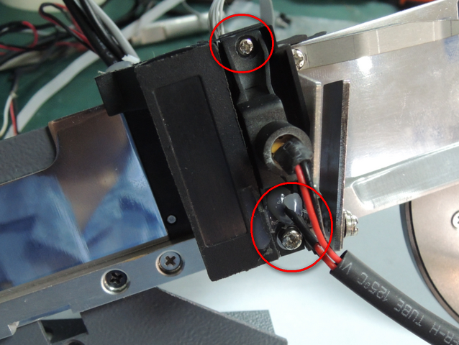
Use the Composed cross recessed pan head screw M2.5*16 and nuts M2.5 to fix light bracket on side board

Use the Composed cross recessed pan head screw M2.5*16 and nuts M3.0 to fix bottom light bracket.
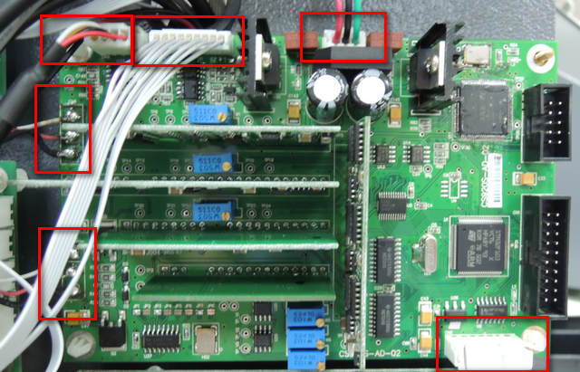
DC shunt cable
CIS cable
geminate transistors
cable
sensor cable (black)

sensor cable (grey)
Cable 327
传感器线束（灰）
分路直流电源线束
对管线束
传感器线束（灰）
7芯线束
分路直流电源线束
传感器线束（黑）
CIS线束
对管线束
传感器线束（灰）
7芯线束
分路直流电源线束
传感器线束（黑）
CIS线束
对管线束
传感器线束（灰）
7芯线束
分路直流电源线束
传感器线束（黑）
CIS线束
对管线束
传感器线束（灰）
7芯线束
分路直流电源线束
传感器线束（黑）
CIS线束

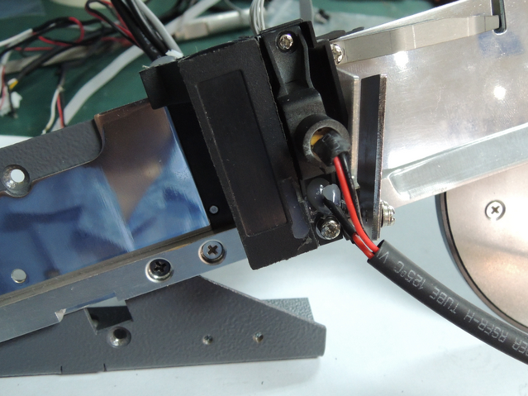
Adjust laser module of the CIS until its test parameter changes 0. After that, use melted glue to fix the laser module on light bracket.
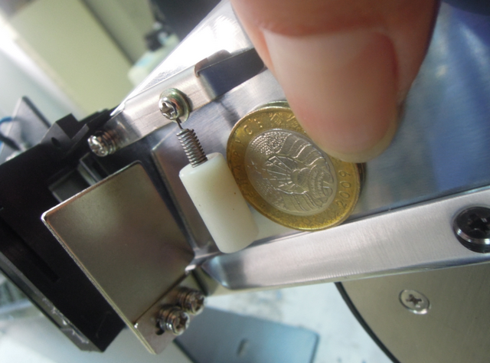
Use the biggest coin to adjust flexibility sensor until make the coin rightly pass through. If the distance is too wide, please use bolt and spring to adjust.

